CosRay at Pole had its origins in 1964 as a neutron monitor installed by Martin Pomerantz. Although it often referred to simply as “the neutron monitor” CosRay has been reinvented and reinvigorated several times over the years. In contrast to investigations that extend the range of IceCube to higher energy CosRay now works with IceTop to extend the range to lower energy (1-10 GeV) primarily to study the acceleration and transport of solar energetic particles. Most of the processes invoked in acceleration models for high energy astrophysical particles also occur on the sun but at different scales. CosRay is funded separately by NSF as event A-118-S. The key, new capability of the partnership with IceTop is resolving the element composition of solar energetic particles in the GeV regime.
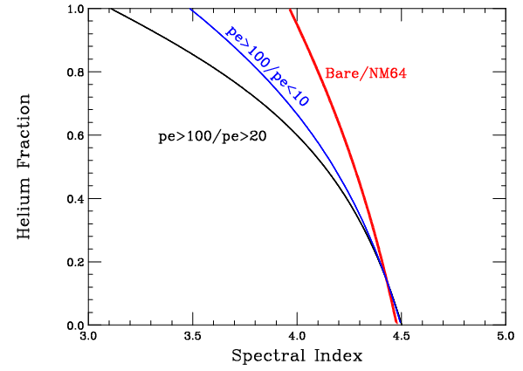
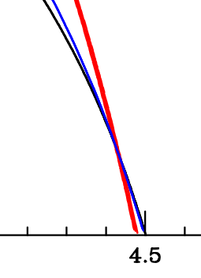
Neutron monitors are air shower detectors like IceTop but with one key difference – the “air showers” are originated by low energy (typically 1-10 GeV) particles that produce only one secondary at the detector. There are two types of neutron monitor operating at Pole. Both use ³He filled proportional counters to count neutrons via the fission reaction n + 3He → p + 3H. Three standard NM-64 are installed on the platform between the station and the clean air facility. NM-64 have proportional counters are embedded in layers of lead and polyethylene. Their peak response is to 100 MeV hadrons (mostly neutrons but also protons) that interact with ²⁰⁸Pb to produce multiple low energy “evaporation” neutrons. These “thermalize” in the polyethylene and are ultimately detected by the proportional counters. The mezzanine in B2-Science houses an array of twelve unleaded (or bare, hence “Polar Bares”) detectors. Unknown composition has traditionally been an important source of error when measuring the spectral index using neutron monitors alone. Figure 1 shows a simulation based on the spectral index and intensity of the large solar flare of 20 January 2005, under the assumption that the particles have the same composition as “galactic” cosmic rays. Statistical errors (+/- one sigma) are represented by the line thickness. Considering the neutron monitor to bare ratio alone, any point on the red curve is equally allowed – in other words the deduced spectral index can range from 4.0 to 4.5 depending on the actual composition.
Figure 1.
With IceTop multiple ratios can be formed from the analog output of the tanks. The black line and blue line in Figure 1 are examples of such ratios. Over some of the parameter space, requiring agreement of the spectral index and composition measured by all of the separate thresholds concurrently could resolve the ambiguity. However the various curves all tend to converge in what is probably the most likely region of parameter space – a helium abundance of 10% or less. When the two types of detector are considered together the ambiguity is resolved. The lines have a well defined intersection at the correct (i.e. simulation input) values of spectrum and helium fraction.

